

Lab One: Free Space and two ray channel Models

[ELG 4179]



October 18, 2022

Nick Cardamone 300060019, 50% Contribution

Nick Reepschlager 300069614, 50% Contribution

# Abstract

In this lab report, the free space channel propagation model is compared against various interpretations of the two ray ground reflection channel propagation model. Statistical sampling of random users are various distances is used to compare the effect of variation of parameters. The results show that the free space model is more optimistic in terms of path loss compared to any of the two ray models in far field. In the near field, the two ray approximation predicts a smaller path loss, while the exact version of the model agrees with the free space model in the near field. That being said, all models presented are valid in the far field only. Consideration is not taken to differentiate between near and far field in this report as that is not the goal. The goal is to compare and contrast the various models to show their similarities and differences.

The code presented in this report is only a portion of the written code. For the complete code see

<https://github.com/ncardamone10/ELG4139>

# Introduction

This lab aims to evaluate the propagation loss of a wireless signal as described by the line of sight (LOS) free space model, and the two-ray model. These models will be observed under several test conditions, varying several of the system’s parameters individually and observing their effects on the path loss. The LOS model assumes a single direct path that the signal takes directly from the transmitter to the receiver. The two-ray model assumes a second path to the receiver, reflected off the ground at some point between the transmitter and receiver. This second ray as it is reflected introduces a phase shift which causes interference at the receiver with the signal sent through line of sight. In the far field, that is, at a long distance, this creates destructive interference as the phase shift is near 180 degrees out of phase. In the near field however, this interference would be constructive and potentially provide more power to the receiver than transmitted. As such, the two-ray model is assumed to only be valid in the far field. Similarly, the LOS model ignores the destructive interference caused by reflections at a large distance, and so is less accurate in the far field. As such, in practice, the propagation loss should be considered as the greater loss between these two models at a given point. For this lab however, both models will be observed at each point, noting the outcome at each distance, whether the model is considered valid at this point or not in order to fully compare the models. Observing the effect on both models of changing test conditions will help better understand what methods can be used to decrease propagation loss.

In this lab, a MATLAB model has been developed using signal frequency, the distance between transmitter and receiver, transmitter and receiver heights, the type of model being used (LOS or two-ray), the ground’s relative permittivity, and the polarization of the field in order to observe the effects of these parameters on the propagation loss. The distance, frequency, and polarization were varied individually for a set of different tests for both models.

The experiment conducted in this lab has applications in many settings in which wireless communication is required. These models are most applicable to signal transmission in wide open environments where the line of sight between transmitter and receiver are uninterrupted. Transmission between two airborne vehicles for example may be a far distance from any reflective surface such as the ground in which a line of sight model applies. Taking the two-ray model into account as well expands the applications to transmission in more rural environments where there is a clear line of sight, as well as a relatively smooth ground for the reflection of a second ray to the receiver.

# Simulation Results

## Part 1

Figure 1: Comparison of 4 Propagation Loss Models

## Part 2

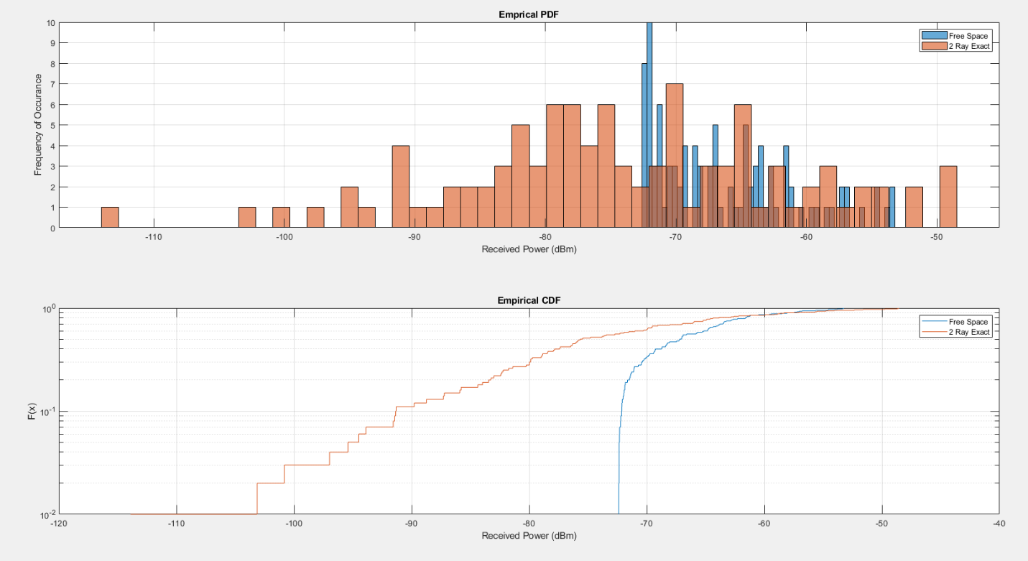

Figure 2: Received Power Distribution, 100 Random Users

## Part 3

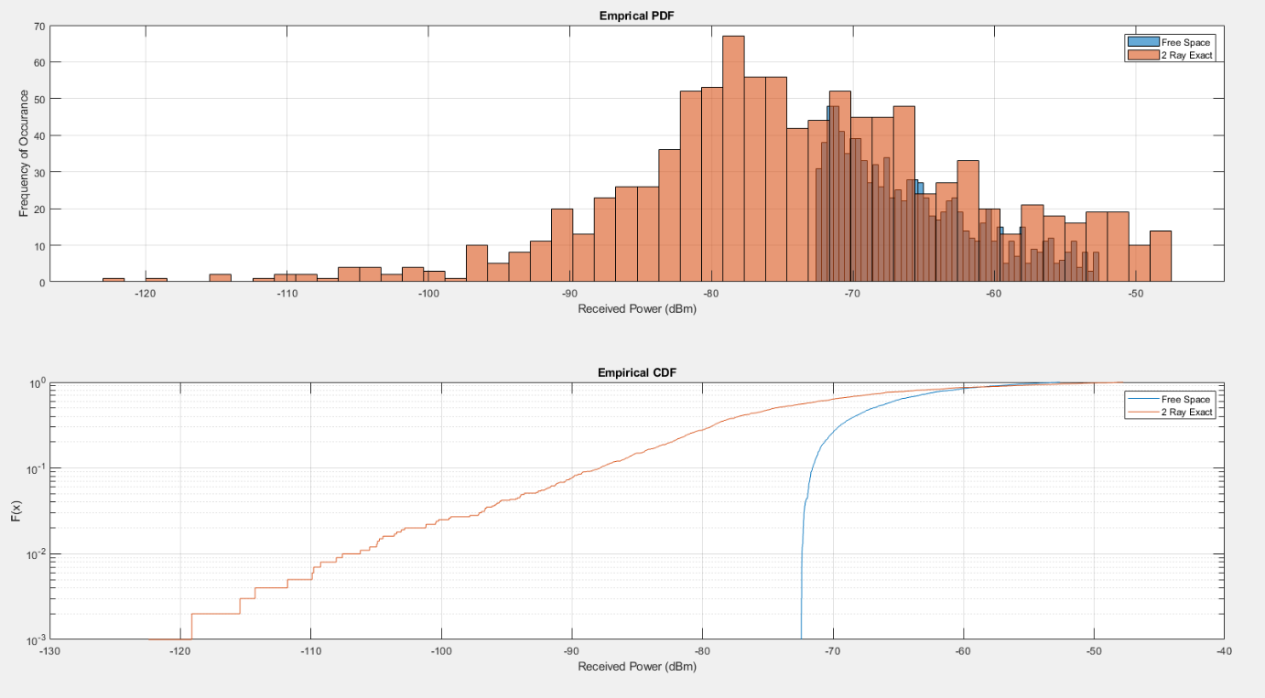

Figure 3: Received Power Distribution, 1000 Random Users

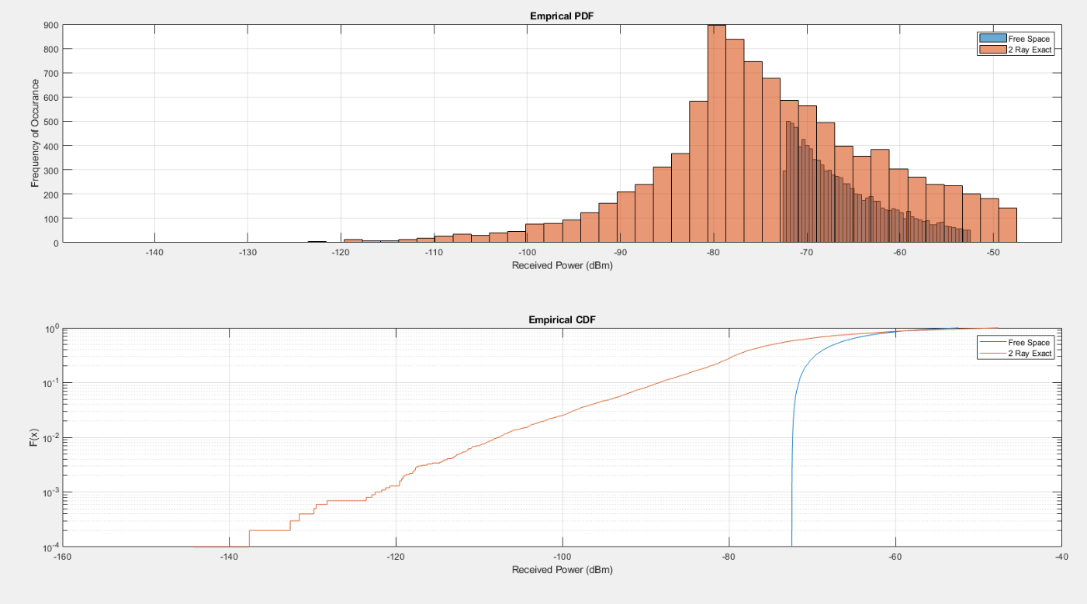

Figure 4: Received Power Distribution, 10,000 Random Users

## Part 4

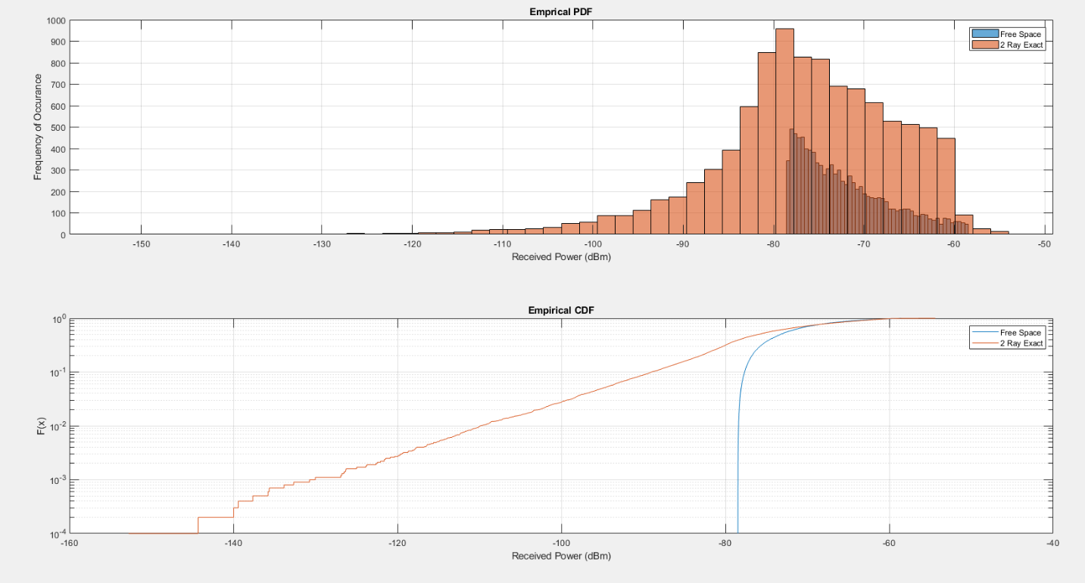

Figure 5: Received Power Distribution, 10,000 Random Users, 2 GHz Carrier Frequency

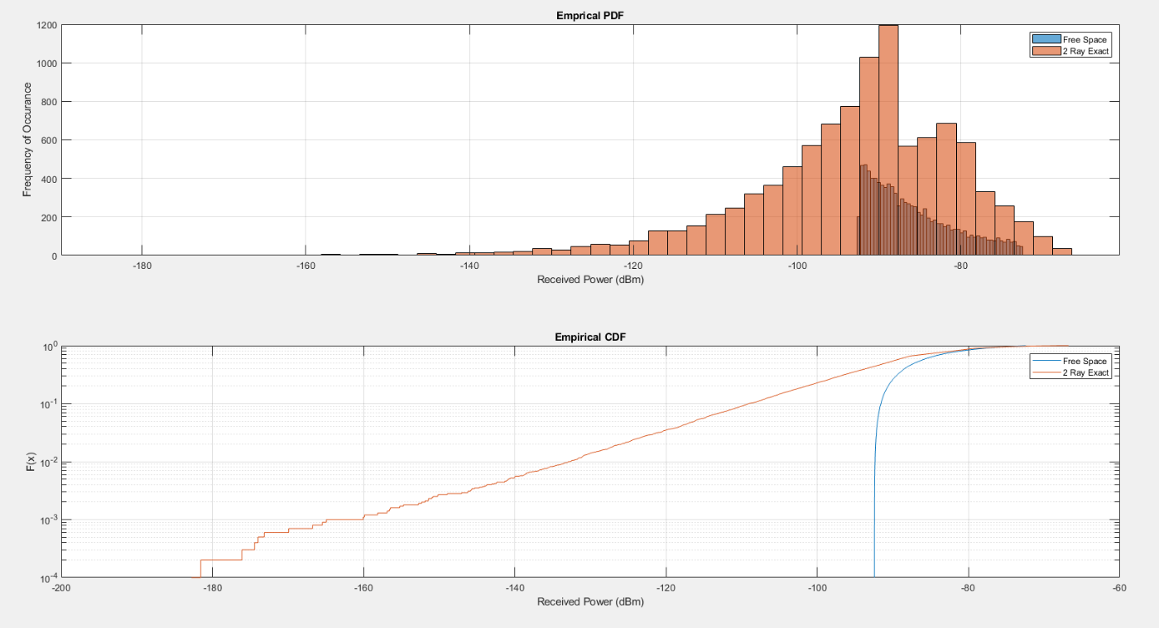

Figure 6: Received Power Distribution, 10,000 Random Users, 10 GHz Carrier Frequency

## Part 5

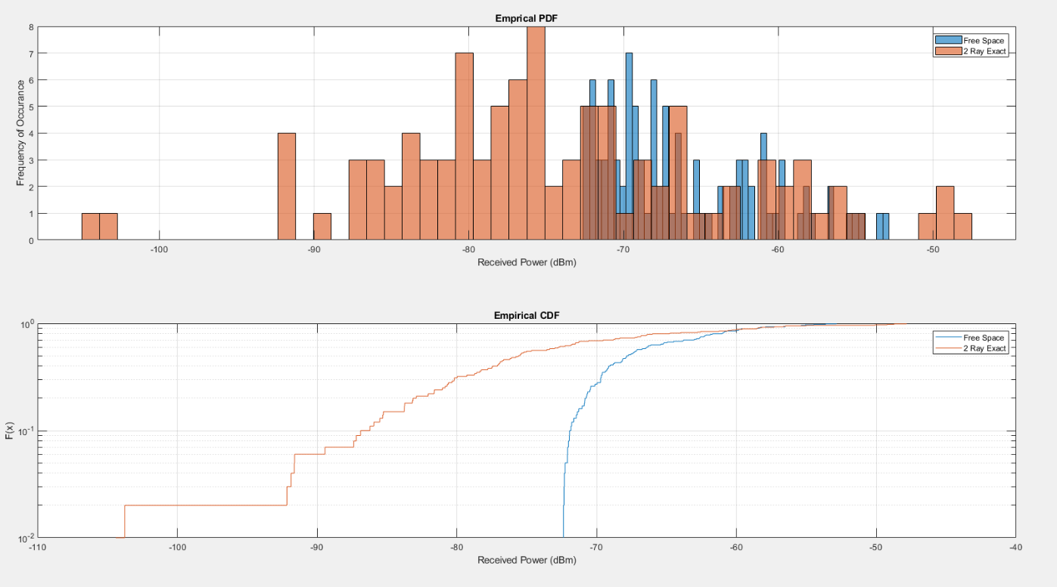

Figure 7: Received Power Distribution, 100 Random Users, 1 GHz Carrier Frequency, Horizontal Polarization

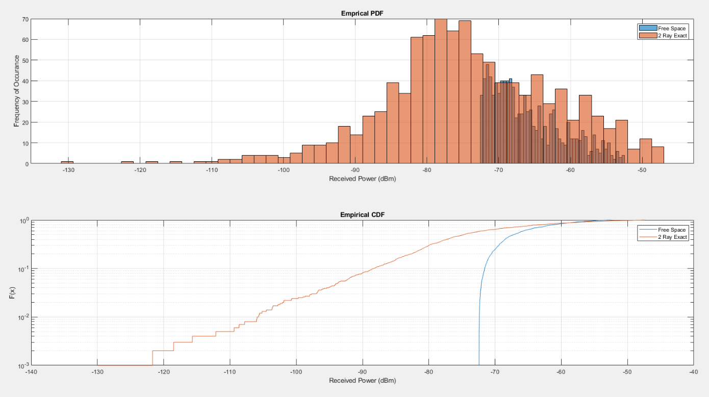

Figure 8: Received Power Distribution, 1000 Random Users, 1 GHz Carrier Frequency, Horizontal Polarization

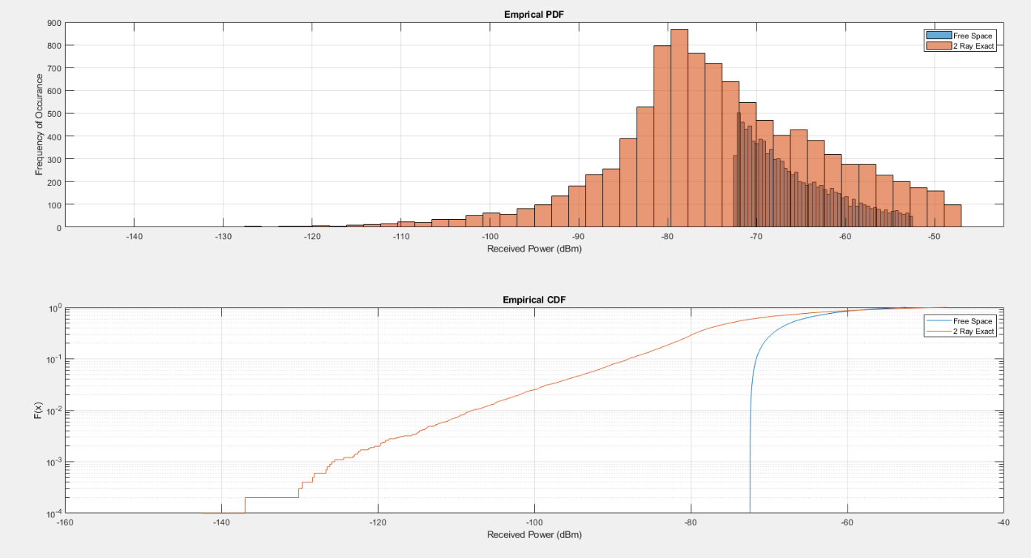

Figure 9: Received Power Distribution, 10,000 Random Users, 1 GHz Carrier Frequency, Horizontal Polarization

## Part 6

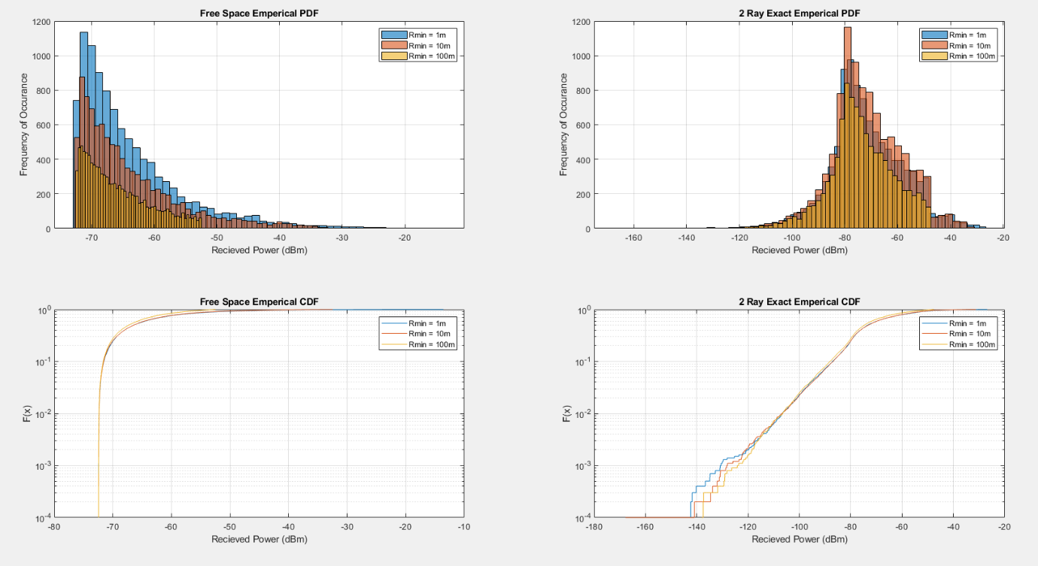

Figure 10: Received Power Distribution, 10,000 Random Users in a Parameterized Distance

## Part 7

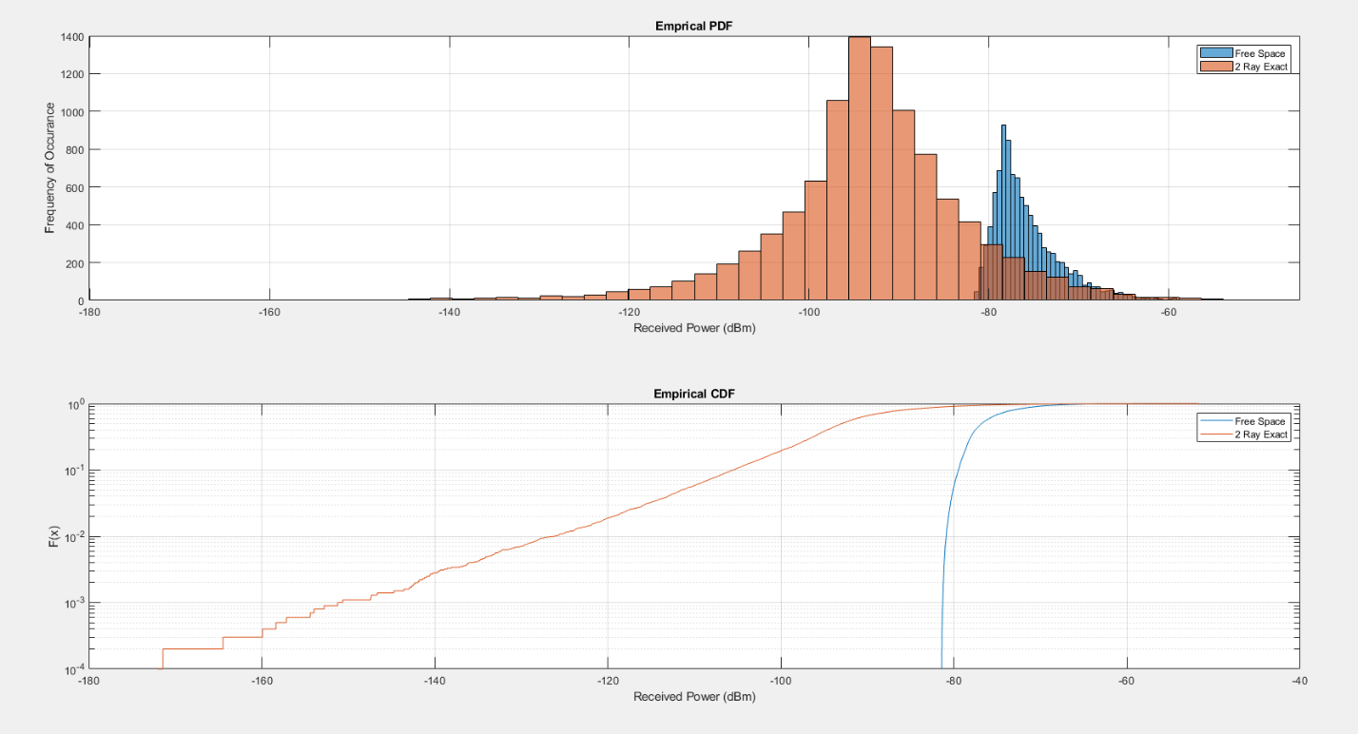

Figure 11: Received Power Distribution, 100 Random Users in a 2x2 km Area

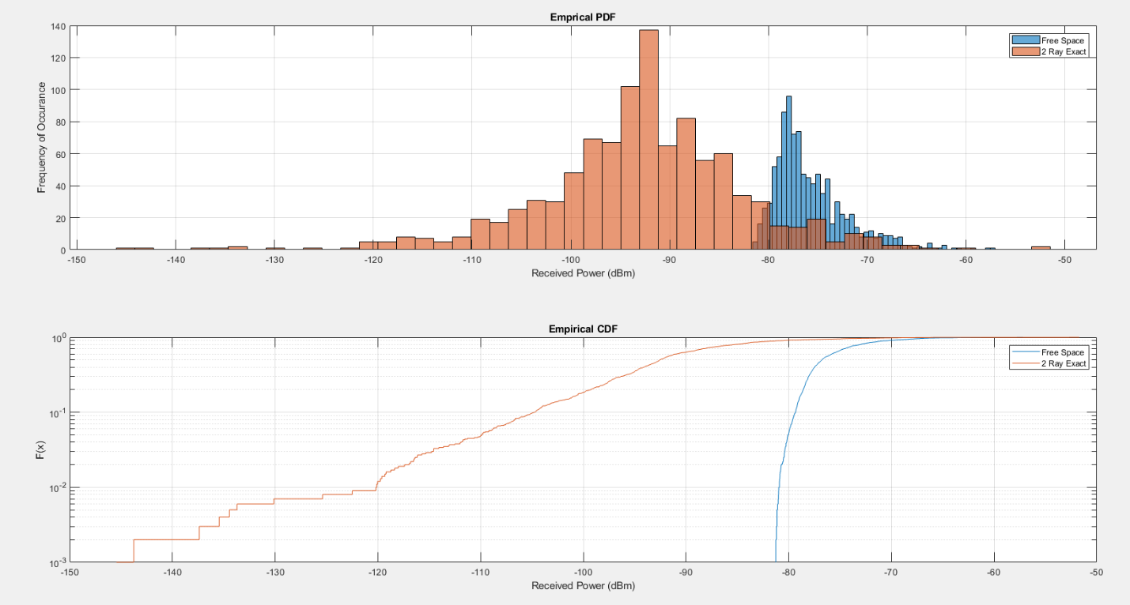

Figure 12: Received Power Distribution, 1000 Random Users in a 2x2 km Area

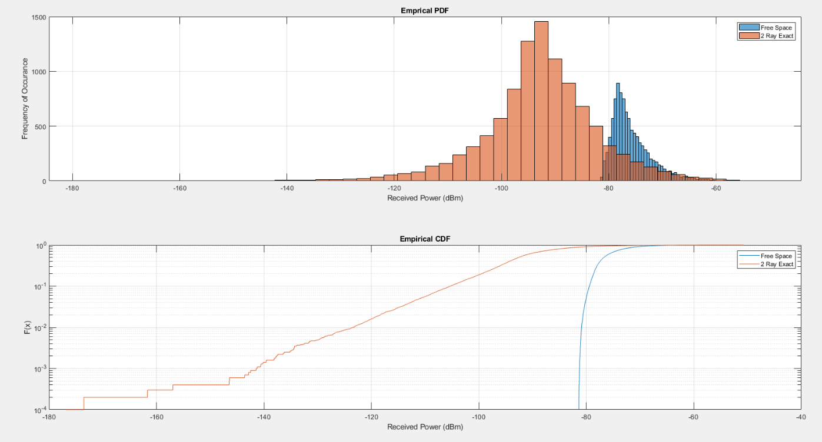

Figure 13: Received Power Distribution, 10,000 Random Users in a 2x2 km Area

# Discussion

## Part 1

In part one, to simulate the path loss for free space and two ray approx., the equations given in the textbook are used. To simulate the two ray exact model, the equations differ from what was given. Instead, the two ray model off of Wikipedia was used. The following are the reference equations used in Figure 1 to generate the two ray exact model (see <https://en.wikipedia.org/wiki/Two-ray_ground-reflection_model>).

Figure 14: Two Ray Illustration







Where

* s(t) : transmitted signal
* l: length (line of sight)
* x+x': length of ground reflected ray
* Ggr, Glos: antenna gain
* E{}: Expected value/ average

The path loss is obtained from dividing out the s(t) and s(t-τ) from both the line of sight and reflected r(t).

The main difference between this model and the two ray model presented in class and the textbook is the extra path loss accumulated at larger distance. This can be explained as the effect of the line of sight and reflected rays cancelling out every half wavelength. To verify this is the case, the following plot is a zoomed in version of figure one. Bear in mind the wavelength has been set to one meter.

Figure 15: Comparison of 4 Propagation Loss Models (Zoomed In)

In addition to the path loss increasing every half wavelength, the envelope also agrees with two ray model approximation. The following is the code used to generate the four models. Major limitation of the presented code is near field and far field bounds are not taken into consideration, nor is radio horizon.

models = {'free space', ...

'2 ray exact horizontal', ...

'2 ray exact vertical', ...

'2 ray approx' };

numberOfPoints = 1000000;

% Distance between Rx and Tx

r = linspace(1, 10000, numberOfPoints);

% Signal Wavelength (m)

lambda = 1;

% Signal Frequency

frequency = 300/lambda*1e6;

% Ground Plane Permittivity

epsilon_r = 16;

% Rx and Tx Antenna Heights

tx_height = 2;

rx_height = 2;

pl = zeros([numberOfPoints, length(models)]);

for M = 1:length(models)

for k = 1:numberOfPoints

pl(k,M) = getPathLoss(frequency, r(k), tx_height, rx_height, epsilon_r, models{M});

end

semilogx(r, -pl(:,M))

hold on

end

grid on

xlabel('Distance (m)')

ylabel('Path Gain (dB)')

title('Path Loss with Different Models')

legend(models)

function PL = getPathLoss(f, r, h_tx, h_rx, epsilon_r, model)

switch model

case 'free space'

PL = getFreeSpacePL(r, f);

case '2 ray exact horizontal'

PL = get2rayExactPL(r, f, h_tx, h_rx, 'horizontal', epsilon_r);

case '2 ray exact vertical'

PL = get2rayExactPL(r, f, h_tx, h_rx, 'vertical', epsilon_r);

case '2 ray approx'

PL = get2rayApproxPL(r, h_tx, h_rx);

otherwise

disp('Invalid Model Requested')

disp('Model Requested: ' + model)

PL = 100000;

end

end

function PL = getFreeSpacePL(r, f)

% Find the wavelength of the signal in meter

lambda = physconst('LightSpeed')/f;

PL = (4*pi*r/lambda)^2;

PL = 10*log10(PL);

end

function PL = get2rayExactPL(distance, frequency, tx_height, rx_height, polarization, epsilon_r)

% Find the wavelength of the signal in meter

lambda = physconst('LightSpeed')/frequency;

% Find the total length of the (ground) reflected ray in meters

ground_ray_length = (tx_height + rx_height)^2 + distance^2;

ground_ray_length = sqrt(ground_ray_length);

% Find line of sight distance

line_of_sight_length = (tx_height - rx_height)^2 + distance^2;

line_of_sight_length = sqrt(line_of_sight_length);

% Find the incedent angle in radians

theta = (tx_height+rx_height)/ground_ray_length;

theta = asin(theta);

% Find permitivity

epsilon = 8.854e-12*epsilon_r;

% Find z based on polarization

switch polarization

case 'horizontal'

z = sqrt(epsilon - (cos(theta))^2);

case 'vertical'

z = sqrt(epsilon - (cos(theta))^2)/epsilon;

otherwise

disp("You didn't enter the polarization correctly")

PL = 100000;

return

end

% Find the reflection coeff

gamma = sin(theta) - z;

gamma = gamma/(sin(theta) + z);

% Find the line of sight path loss

path_loss_line_of_sight = 4*pi*line_of_sight_length;

path_loss_line_of_sight = lambda/path_loss_line_of_sight;

path_loss_line_of_sight = exp(-j*2*pi*line_of_sight_length/lambda)*path_loss_line_of_sight;

path_loss_line_of_sight = real(path_loss_line_of_sight);

% Find the ground reflected ray path loss

path_loss_reflected_ray = 4*pi*ground_ray_length;

path_loss_reflected_ray = lambda*gamma/path_loss_reflected_ray;

path_loss_reflected_ray = exp(-j*2*pi*ground_ray_length/lambda)*path_loss_reflected_ray;

path_loss_reflected_ray = real(path_loss_reflected_ray);

% Find the exact 2 ray path loss

path_loss_2ray = path_loss_reflected_ray + path_loss_line_of_sight;

path_loss_2ray = path_loss_2ray^2;

path_loss_2ray = 1/path_loss_2ray;

PL = 10*log10(path_loss_2ray);

end

function PL = get2rayApproxPL(distance, tx_height, rx_height)

PL = distance^4/(tx_height^2*rx_height^2);

PL = 10*log10(PL);

end

## Part 2

In figure two, the major difference between the two ray and free space received power distributions is the mean. Since the two ray model predicts larger path loss for distances greater than 100 m or so, it is expected for the PDF associated with the two ray model to have a smaller average received power.

The following is the code used to generate the plots.

% Number of Users

numberOfPoints = 100;

% Field Polarization for 2-Ray Model (Reflection Coeff)

polarization = 'vertical';

% Signal Frequency

frequency = 1e9;

% Minimum Distance (m)

dMin = 0.1*10^3;

% Maximum Distance (m)

dMax = 1*10^3;

% Creating RV of distances

distances = rand([1 numberOfPoints]);

distances = distances*(dMax - dMin);

distances = distances + dMin*ones(size(distances));

% Get Plots

h = getPDFandCDF(numberOfPoints, frequency, polarization, distances);

function h = getPDFandCDF(numberOfPoints, frequency, polarization, distances)

% Tx Power

Ptx = 100; % TX Power in Watts

PtxdBm = 10*log10(Ptx);

% Ground Relitive Permittivity

epsilon_r = 15;

% Antenna Gains

Gtx = 1; % linear units

Grx = 1;

GtxdB = 10*log10(Gtx);

GrxdB = 10*log10(Grx);

% Antenna Heights (m)

htx = 10;

hrx = 1;

% Get RX Power for Free Space Model over N random users

PrxdBm_freeSpace = zeros(size(distances));

for k = 1:numberOfPoints

pathLossdB = getPathLoss(frequency, distances(k), htx, hrx, epsilon_r, 'free space');

PrxdBm_freeSpace(k) = PtxdBm + GrxdB + GtxdB - pathLossdB;

end

% Get RX Power for 2 Ray Exact over N random users

PrxdBm_2rayExact = zeros(size(distances));

for k = 1:numberOfPoints

pathLossdB = getPathLoss(frequency, distances(k), htx, hrx, epsilon_r, append('2 ray exact ', polarization));

PrxdBm_2rayExact(k) = PtxdBm + GrxdB + GtxdB - pathLossdB;

end

% Emprical PDFs

subplot(2,1,1)

h(1,1) = histogram(PrxdBm_freeSpace, 50);

hold on

h(1,2) = histogram(PrxdBm_2rayExact, 50);

legend('Free Space', '2 Ray Exact')

grid on

xlabel('Received Power (dBm)')

ylabel('Frequency of Occurance')

title('Emprical PDF')

subplot(2,1,2)

h(2,1) = cdfplot(PrxdBm_freeSpace);

set(gca,'YScale','log')

xlabel('Recieved Power (dBm)')

hold on

h(2,2) = cdfplot(PrxdBm_2rayExact);

set(gca,'YScale','log')

xlabel('Received Power (dBm)')

legend('Free Space', '2 Ray Exact')

end

## Part 3

The difference between the plots is the horizontal resolution of sorts. With more random users and more data points, the empirical PDF and CDF become closer to the theoretical models.

The code used to generate these plots is the same as part two with the number of users changed to 1000 and 10,000.

## Part 4

The difference between these plots and those of the previous part is the carrier frequency has been bumped up. As such, the expected received power has been decreased. This is because frequency to some positive power is generally proportional to the path loss.

The code used to generate these plots is the same as in part two except with the frequency changed to 2 and 10 GHz respectively.

## Part 5

In this part, changing the polarization from vertical to horizontal doesn’t have much of an effect on the path loss predicted by the two-ray model. In the free space model, polarization is neglected and makes no difference.

The code used to generate these plots is the same as in part two with respective parameters changed.

## Part 6

In this part, we are varying the minimum distance between the transmitter and receiver. One would expect for this to cause a noticeable change in the output PDFs and CDFs but that is not the case. This can be seen from the definition near field for the two ray model. It is as follows.

In this case, R or the distance must be greater than about 700 meters. Since we are only varying the minimum distance from 1 to 100 meters, there is no significant difference between the PDFs.

The code used to generate these plots is as follows.

% Number Of Users

numberOfPoints = 10000;

% 2-Ray Polarization

polarization = 'vertical';

% Signal Frequency

frequency = 1e9;

% Vector of Min Distances

dMin = [1 10 100];

% Max Distance

dMax = 1*10^3;

% TX Power

Ptx = 100; % TX Power in Watts

PtxdBm = 10*log10(Ptx);

% Ground Permittivity

epsilon_r = 15;

% Antenna Gains

Gtx = 1; % linear units

Grx = 1;

GtxdB = 10*log10(Gtx);

GrxdB = 10*log10(Grx);

% Tx and Rx Heights

htx = 10;

hrx = 1;

legendText = {};

for l = 1:length(dMin)

distances = rand([1 numberOfPoints]);

distances = distances*(dMax - dMin(l));

distances = distances + dMin(l)*ones(size(distances));

% Get RX Power for Free Space Model over 100 random users

PrxdBm_freeSpace = zeros(size(distances));

for k = 1:numberOfPoints

pathLossdB = getPathLoss(frequency, distances(k), htx, hrx, epsilon_r, 'free space');

PrxdBm_freeSpace(k) = PtxdBm + GrxdB + GtxdB - pathLossdB;

end

% Get RX Power for 2 Ray Exact over 100 random users

PrxdBm_2rayExact = zeros(size(distances));

for k = 1:numberOfPoints

pathLossdB = getPathLoss(frequency, distances(k), htx, hrx, epsilon_r, append('2 ray exact ', polarization));

PrxdBm_2rayExact(k) = PtxdBm + GrxdB + GtxdB - pathLossdB;

end

subplot(2,2,1)

h(1,1) = histogram(PrxdBm_freeSpace, 50);

hold on

grid on

xlabel('Recieved Power (dBm)')

ylabel('Frequency of Occurance')

title('Free Space Emperical PDF')

subplot(2,2,2)

h(1,2) = histogram(PrxdBm_2rayExact, 50);

hold on

grid on

xlabel('Recieved Power (dBm)')

ylabel('Frequency of Occurance')

title('2 Ray Exact Emperical PDF')

subplot(2,2,3)

h(2,1) = cdfplot(PrxdBm_freeSpace);

set(gca,'YScale','log')

hold on

grid on

xlabel('Recieved Power (dBm)')

title('Free Space Emperical CDF')

subplot(2,2,4)

h(2,2) = cdfplot(PrxdBm_2rayExact);

set(gca,'YScale','log')

hold on

grid on

xlabel('Recieved Power (dBm)')

title('2 Ray Exact Emperical CDF')

legendText{l} = append("Rmin = ", int2str(dMin(l)), 'm');

end

subplot(2,2,1)

legend(legendText)

subplot(2,2,2)

legend(legendText)

subplot(2,2,3)

legend(legendText)

subplot(2,2,4)

legend(legendText)

## Part 7

In this part, the results are similar to those of parts two and three but with a slightly different PDF shape and an increased mean path loss. This can be seen from the fact that we are using the hypotonus as our random distance instead of a single line segment. If we take two random line segments and form a triangle from them, we expect the resulting distance to be larger than a single line segment. Since this distance is larger, the path loss will also be larger.

The code used to generate these plots are as follows.

% Line Segment Bounds (m)

dMin = 100;

dMax = 2000;

% Number of Users

numberOfPoints = 100;

% Create Random Line Lengths

x = rand([1 numberOfPoints]);

x = x*(dMax - dMin);

x = x + dMin*ones(size(x));

y = rand([1 numberOfPoints]);

y = y*(dMax - dMin);

y = y + dMin*ones(size(y));

% Create Hypotonuses

distances = x.^2 + y.^2;

distances = sqrt(distances);

% Get PDFs and CDFs

h = getPDFandCDF(numberOfPoints, frequency, polarization, distances);

## Part 8

Assuming a flat and identically distributed terrain, no it does not matter if the base station and receiver positions are swapped. This is due to relativity.

# Conclusion

To conclude, this report examined the differences between the exact two ray model and the free space model. In part, the free space model was shown to be more optimistic than the 2 ray model (both approximate and exact). In addition to that, the exact free space model showed phase cancellation of the line of sight and reflected ray every half wavelength, which is not present in the typical exact model shown in the textbook. In parts two through five, the two models were compared while varying various parameters. The two ray model generally had a lower average received power than the free space model. In part six the minimum distance between the base station and transmitter were examined. The results showed that this variation didn’t really matter as the variations existed in the near field only. Finally in part seven and eight, random users were placed in a square area and the received power was analysed scholastically.